Independent
May 5 – 8, 2022
OVR Checklist

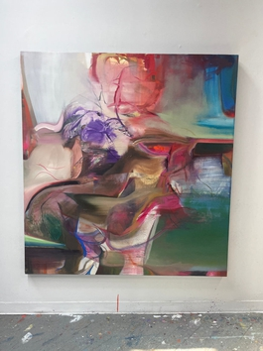 | Grace Carney  [Untitled]- WORK IN PROGRESS, 2023  oil on canvas  63 x 66 7/8 ins.  160 x 170 cm  (CARNEY-014)
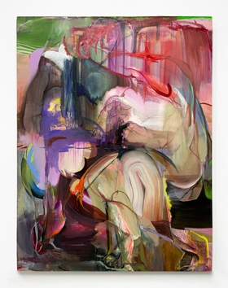 | Grace Carney  Rose, 2023  oil on canvas  66 7/8 x 51 1/8 ins.  169.9 x 129.9 cm  (CARNEY-017)
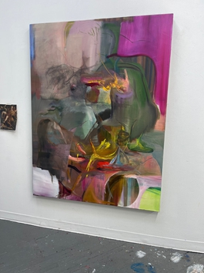 | Grace Carney  [Untitled]- WORK IN PROGRESS, 2023  oil on canvas  66 7/8 x 51 1/8 ins.  169.9 x 129.9 cm  (CARNEY-018)
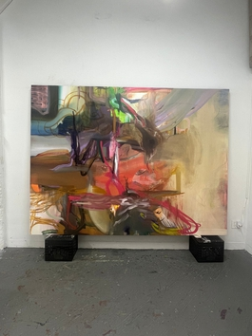 | Grace Carney  [Untitled]- WORK IN PROGRESS, 2023  oil on canvas  75 x 100 ins.  190.5 x 254 cm  (CARNEY-019)
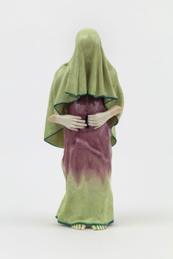 | Jessica Stoller  Untitled (fate), 2022  porcelain, glaze  9 1/2 x 3 1/2 x 3 ins.  24.1 x 8.9 x 7.6 cm  (STOLLER-159)
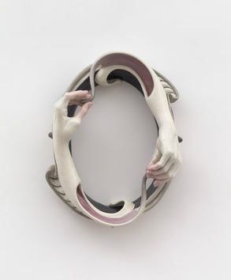 | Jessica Stoller  TBC - UNTITLED, 2022  porcelain, glaze  13 1/2 x 10 1/2 x 4 1/2 ins.  34.3 x 26.7 x 11.4 cm  (STOLLER-160)
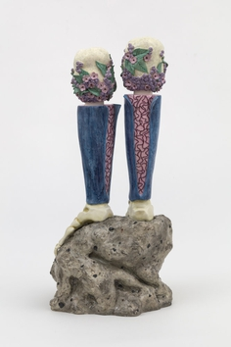 | Jessica Stoller  TBC - UNTITLED, 2022  porcelain, glaze  20 3/4 x 9 x 10 ins.  52.7 x 22.9 x 25.4 cm  (STOLLER-161)
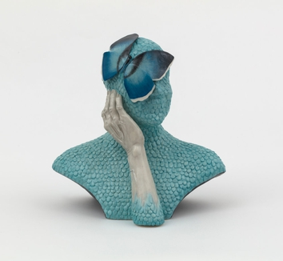 | Jessica Stoller  TBC - UNTITLTED, 2022  porcelain, glaze  12 x 12 x 8 ins.  30.5 x 30.5 x 20.3 cm  (STOLLER-166)
Grace Carney
[Untitled]- WORK IN PROGRESS, 2023

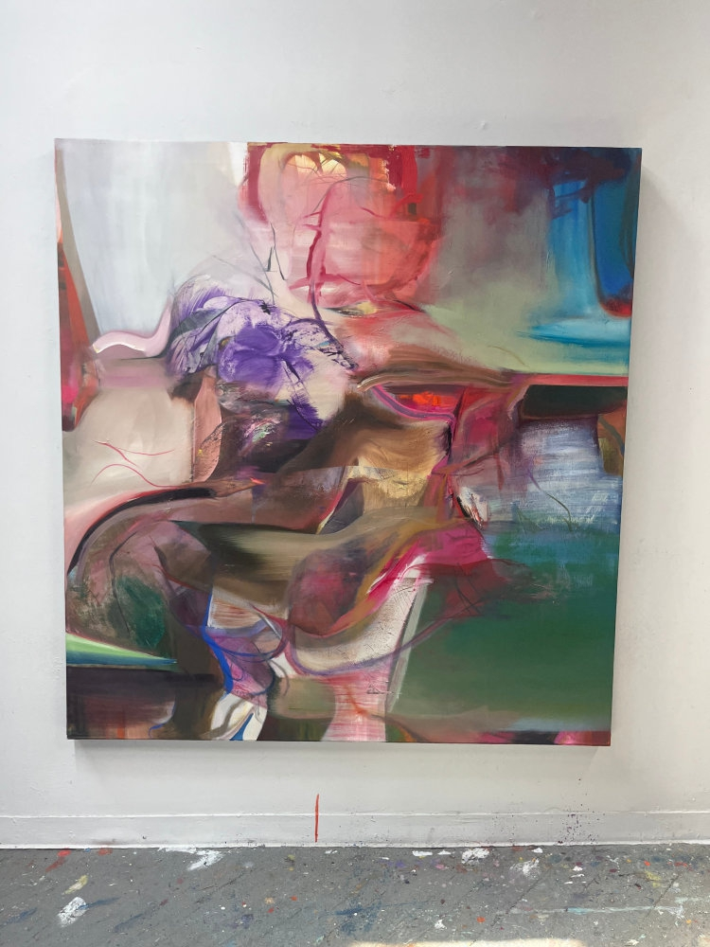

oil on canvas
63 x 66 7/8 ins.
160 x 170 cm
(CARNEY-014)

$ 25,000.00
Grace Carney
Rose, 2023

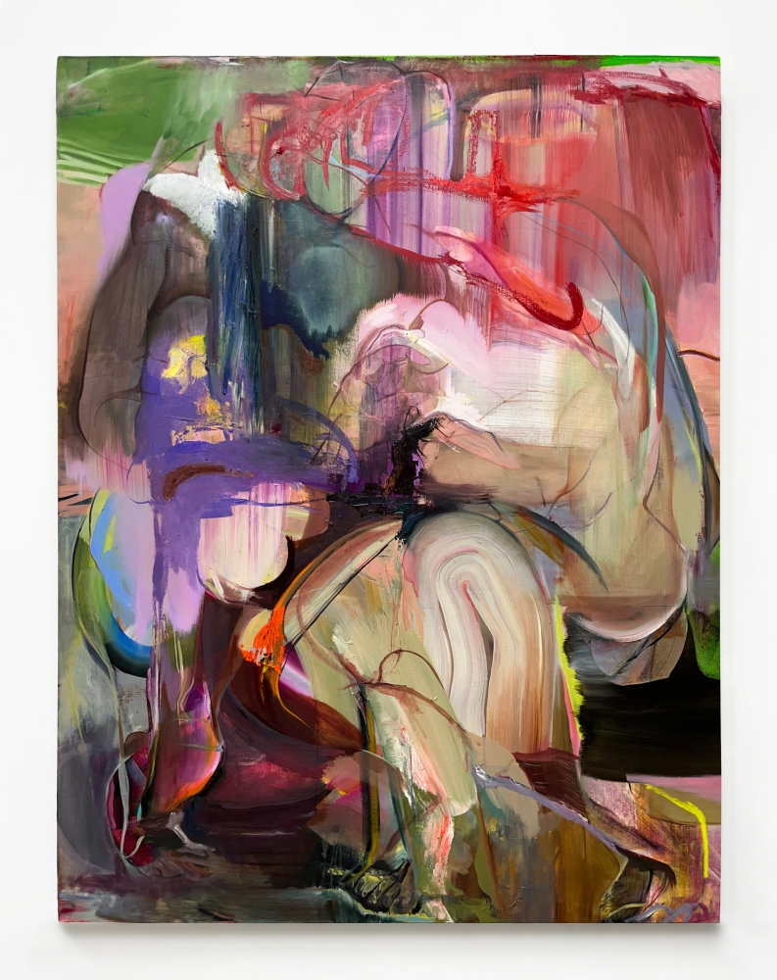

oil on canvas
66 7/8 x 51 1/8 ins.
169.9 x 129.9 cm
(CARNEY-017)

$ 20,000.00
Grace Carney
[Untitled]- WORK IN PROGRESS, 2023

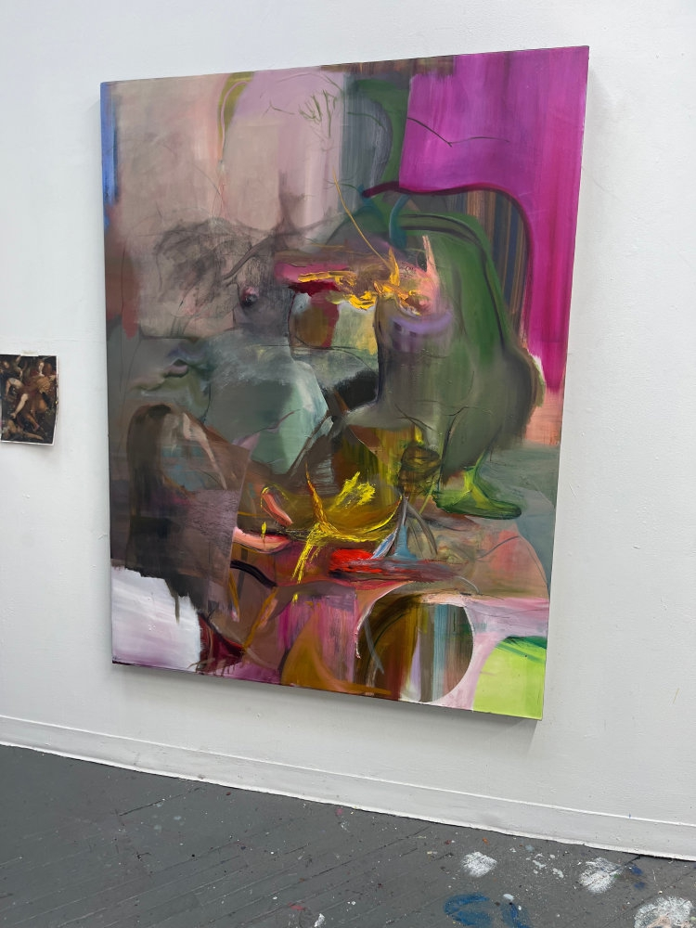

oil on canvas
66 7/8 x 51 1/8 ins.
169.9 x 129.9 cm
(CARNEY-018)

$ 20,000.00
Grace Carney
[Untitled]- WORK IN PROGRESS, 2023

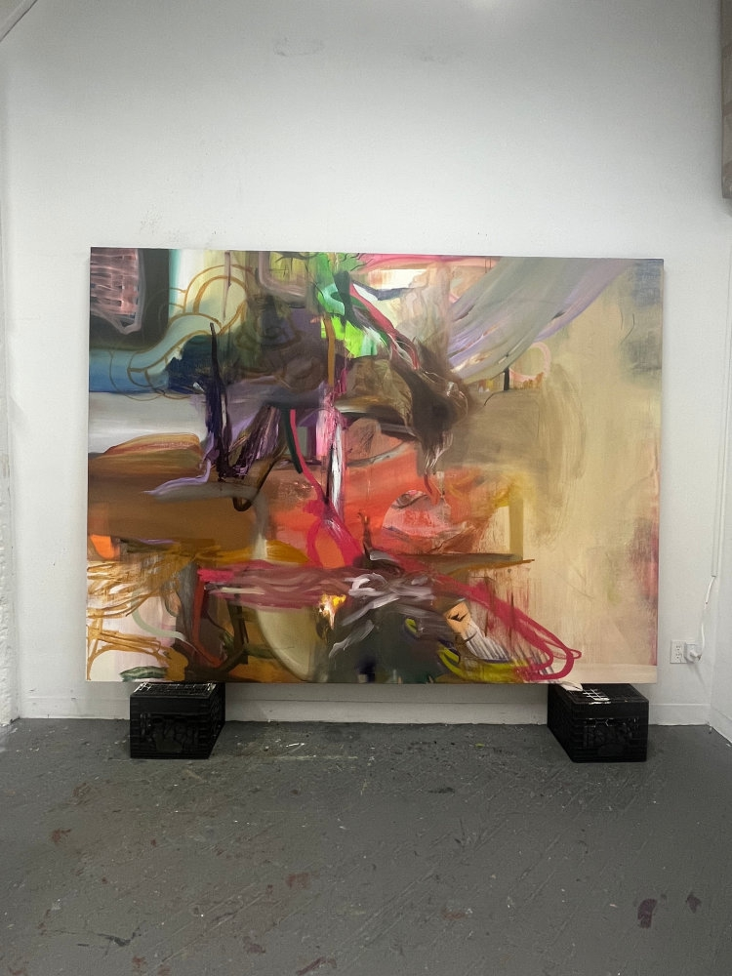

oil on canvas
75 x 100 ins.
190.5 x 254 cm
(CARNEY-019)

$ 45,000.00
Jessica Stoller
Untitled (fate), 2022

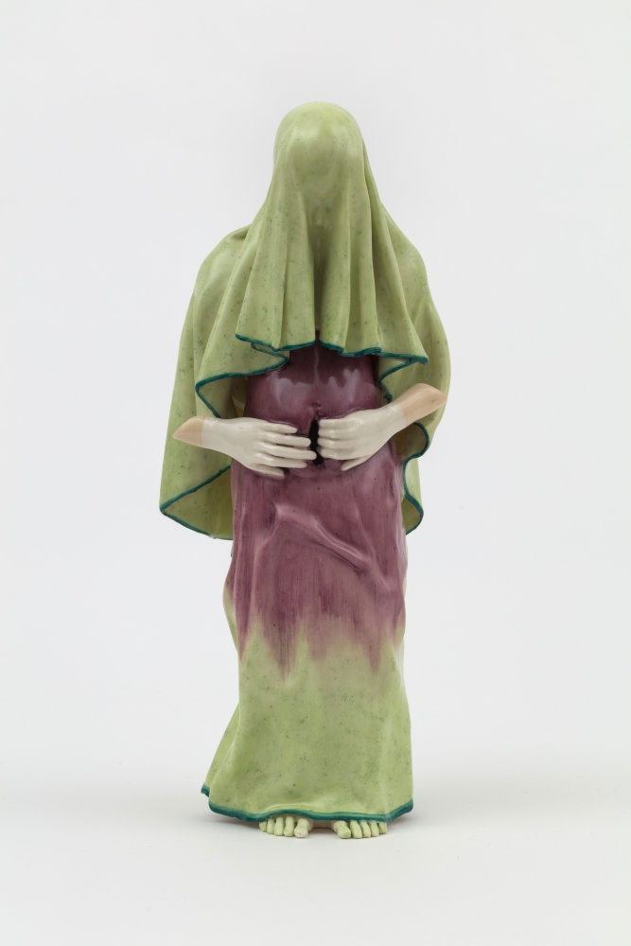

porcelain, glaze
9 1/2 x 3 1/2 x 3 ins.
24.1 x 8.9 x 7.6 cm
(STOLLER-159)
Jessica Stoller
TBC - UNTITLED, 2022

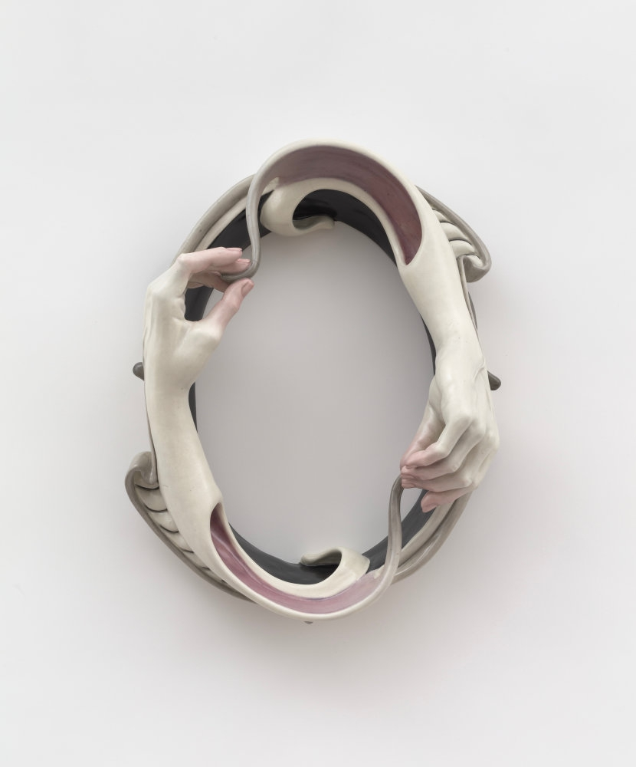

porcelain, glaze
13 1/2 x 10 1/2 x 4 1/2 ins.
34.3 x 26.7 x 11.4 cm
(STOLLER-160)
Jessica Stoller
TBC - UNTITLED, 2022

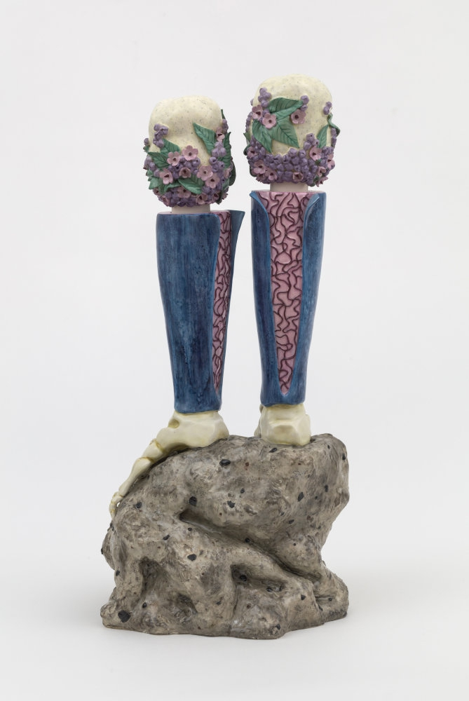

porcelain, glaze
20 3/4 x 9 x 10 ins.
52.7 x 22.9 x 25.4 cm
(STOLLER-161)
Jessica Stoller
TBC - UNTITLTED, 2022

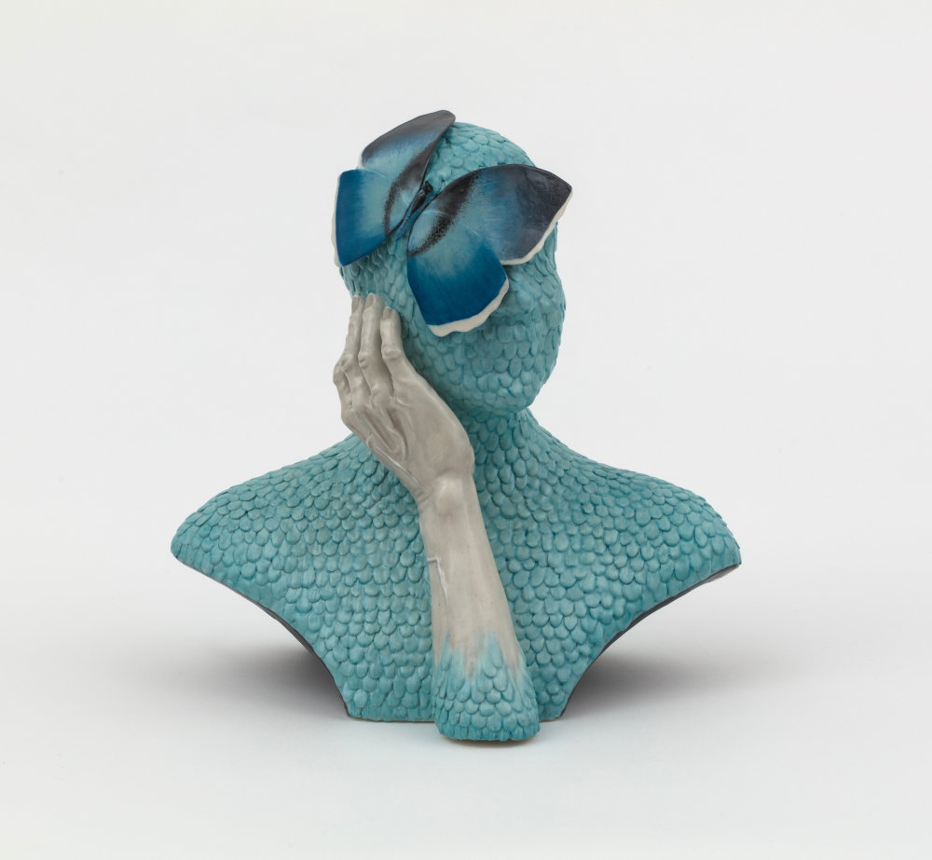

porcelain, glaze
12 x 12 x 8 ins.
30.5 x 30.5 x 20.3 cm
(STOLLER-166)

